
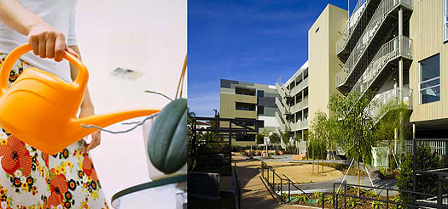
Please Join Us for: An Afternoon of Patio Culture in the Park.
Habitat on the Park – 12 Designer Condominiums
1351 Havenhurst Avenue, West Hollywood
deasy/penner&partners and tvoa.net present both a speaking engagement with Katherine Spitz, Landscape Architect and designer of the Habitat Park and Karla Stevens, owner of Patio Culture—a premiere outdoor living and entertaining accessories boutique.
Katherine will be on-site to discuss creation and design of the new Havenhurst pocket-park. Patio Culture will host a “Trunk Show” of some special items – with 10 percent of proceeds raised to benefit APLA. Guests will have the opportunity to tour the project; a donation is suggested at the door.
When: | Sunday, December 14, 2008
 | 2:00 – 4:00pm
Where: | 1351 Havenhurst Avenue, West Hollywood
Please RSVP to blinder@tvoa.net or call 800.684.8862.
Visit www.habitatonthepark.com.
Recently completed, 'Habitat on the Park' is a new four story contemporary building in the heart of West Hollywood. Centrally located and configured around a tranquil garden park by landscape architect Katie Spitz. Composite panels and cedar planks create a modern aesthetic. Glass apertures capture voluminous light resulting in a creative and livable design. A mixture of 1, 2 and 3 bedrooms some with lofts/mezzanines, feature contemporary European kitchens, private patio balconies, gated subterranean parking. By Habitat Group Los Angeles - an award-winning boutique developer.

