

Beginning 1/02/09, Submissions Accepted for 10th Annual Wayne Grace Student Design Competition
The Landscape Architectural Registration Boards Foundation (LARBF) announces the 10th annual Wayne Grace Student Design Competition.
This competition recognizes outstanding examples of landscape architectural work by students that demonstrate how the practice of landscape architecture and licensing affects quality of life.

The competition is open to any student or team of students currently enrolled in an undergraduate or graduate Landscape Architectural Degree Program. Submissions may pertain to any project which affects the natural and built environment and has a demonstrated, positive impact on the quality of life of the public. In prior years, a number of landscape architecture programs have successfully incorporated the competition into their academic curriculum. We invite programs in universities and colleges from around the country to consider taking part in this competition. Submissions will be accepted January 2, 2009 through May 29, 2009.

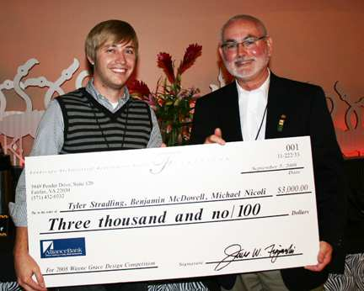
Three winning submissions will be chosen. The first-place winner will receive a $3,000 cash award and will be recognized during an awards ceremony at CLARB's Annual Meeting in September 2009. The second-place winner will receive a $2,000 cash award, and the third-place winner will receive a $1,000 cash award. The winning submission(s) are published nationally and distributed to legislators and related design professionals across North America.

The Wayne Grace Student Design Competition commemorates Wayne Grace, who dedicated his life to the practice of landscape architecture and the advancement of the cause of licensure.

View the details of the 2008 competition won by a team of students from Arizona State University. (The photo above shows one of the students from the winning team, Tyler Stradling, accepting his team's cash award from LARBF President Jim Figurski at the CLARB Annual Meeting on September 5, 2008.)

For additional information, please contact Missy Sutton at 571-432-0332 x113.

Landscape Architectural Boards Foundation
c/o CLARB
3949 Pender Drive
Suite 120
Fairfax, VA 22030
Phone: 571-432-0332
Fax: 571-432-0442
WWW.CLARB.ORG

