A message to all members of BeLoose Graphic Workshop

Dear BeLoose Member:
How often do you need to render an outdoor space with many trees and shrubs? Here are our suggestions:
- Apply leaves using different colors; Front - blueish green. Back - yellowish green.
- Use different sizes of leaf: Front - larger leaves. Back - smaller leaves.
- Use different value: Front - darker value. Back - lighter value.
- Use different leaf languages: concave, convex, round lobe for deciduous (McDonald and Wendy) and pointed lobe for evergreen. This method can delineate 4 different plants.
In the following example, you can see how the above tips are applied. Don't render the waterfall, leave it blank with very little blue. Apply very light orange (Sunset Pink) to horizon to compliment the blue sky. Apply 3 amigos colors (known as color glow) - Maize, Sunset Pink and Sapphire Blue) on stone wall and vegetation. Render darker on trunk under leaves. Make sure the entire drawing should be outlined with black pen (LePen) or prismacolor pencil. We used the Chartpak Markers and colors are as follows:
Front tree: Willow Green, Grass Green, Nile Green
Back tree: Cream, Pale Olive, Olive
Purple tree: Violet Light, Purple Sage, Purple Iris
Stone wall and floor: Cool Gray 1,2,3,5
Sky and water: Sapphire Blue, Blue Glow, Sky Blue
Other colors: Sunset Pink, Maize, Linden Green
Outlined with LePen and make sure you don't use another thicker pen.
Hope you will take an hour and practice it with our suggestions. We will continue to add more techniques and tips in our future e-mails. If you have any questions or comments, please go to our web site and write a blog, so we will respond.
Thanks for your attention and we hope to make our web site to become a very resourceful site for your career advancement.
Mike Lin
Brian Lin
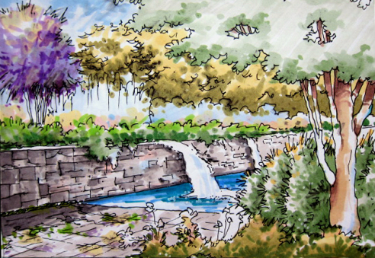

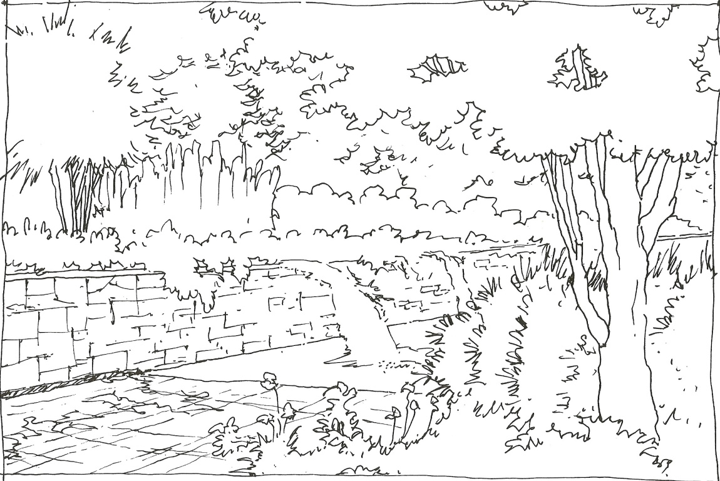
Visit BeLoose Graphic Workshop at: http://www.beloose.com/?xg_source=msg_mes_network

