A message to all members of BeLoose Graphic Workshop
Render Landscape Plan
How you can render a landscape plan professionally with the following easy steps:
- Outline your landscape plan with pen (LePen used). Tips use: straight edge, circle template, overlap corner, professional dot and professional gap.
- Outline two trees with heavier Sharpie pen next to thinner pen as they are closer to your eyes.
- We used Chartpak Markers to render the plan and highlighted with Prismacolor pencils.
- Water: Use Colorless Blender, Sapphire Blue, Blue Glow and Sky Blue, Tips used: Darker to the edge and gradual to the white space, Add orange sculpture for Color Pair (complimentary). Apply Gradual Value Change carefully using Blender.
- Berm: Use Willow Green, Grass Green, Nile Green.
- Grass: Use Willow Green, Grass Green, Nile Green, Linden Green, Blue Green, Darken colors toward shrubs and lighten them toward the edge of paper.
- Concrete pavement: Use Cool Grey 1, 2, 3, Colorless Blender, Sunset Pink, Maize, Sapphire Blue. Apply plenty of blender to lighten other colors
- Groundcover in the planter: Willow Green, Grass Green, Prismacolor Pencils – True Blue, Orange, Canary Yellow, Lilac.
- Bench: Colorless Blender, Buff, Suntan and Mocha for shadow
- Brick paver: Powder Pink, Salmon, Deep Salmon, Scarlet with Maroon for shadow
- Tree shadow: Cool Grey 5 or 7.
You are encouraged to print out the lined original drawing and see how close you can render close to the color one. If interested in the Chartpak’s 47 colors set, please go to:
http://www.beloose.com/page/art-supply

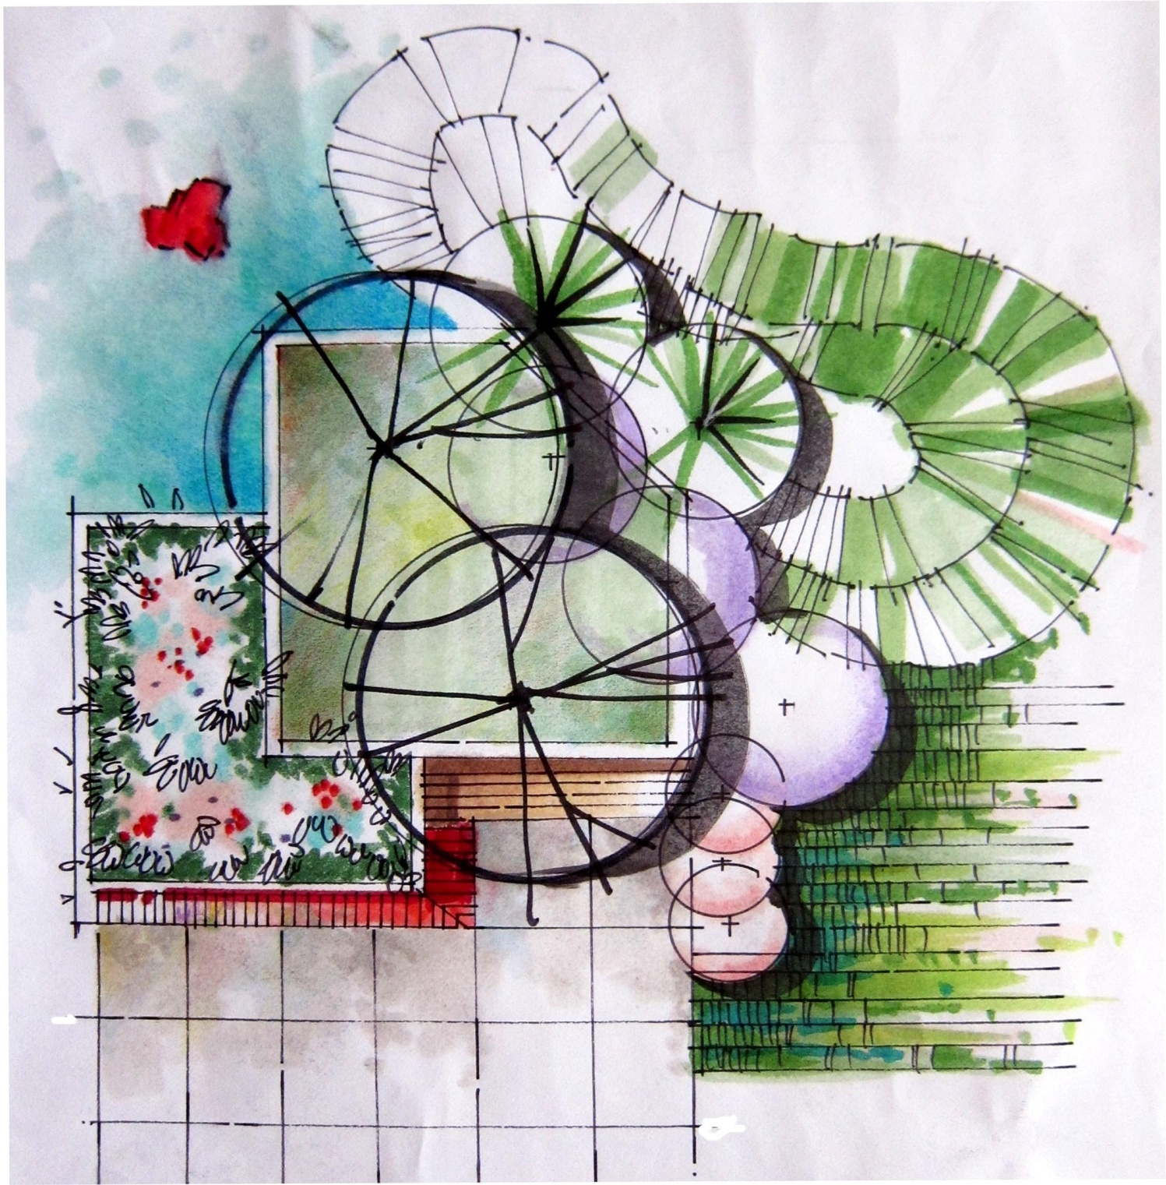
Copy right by BeLoose Graphic Workshop. This image is for personal use only; intend to use in academic, office or other workshop is strictly prohibited.
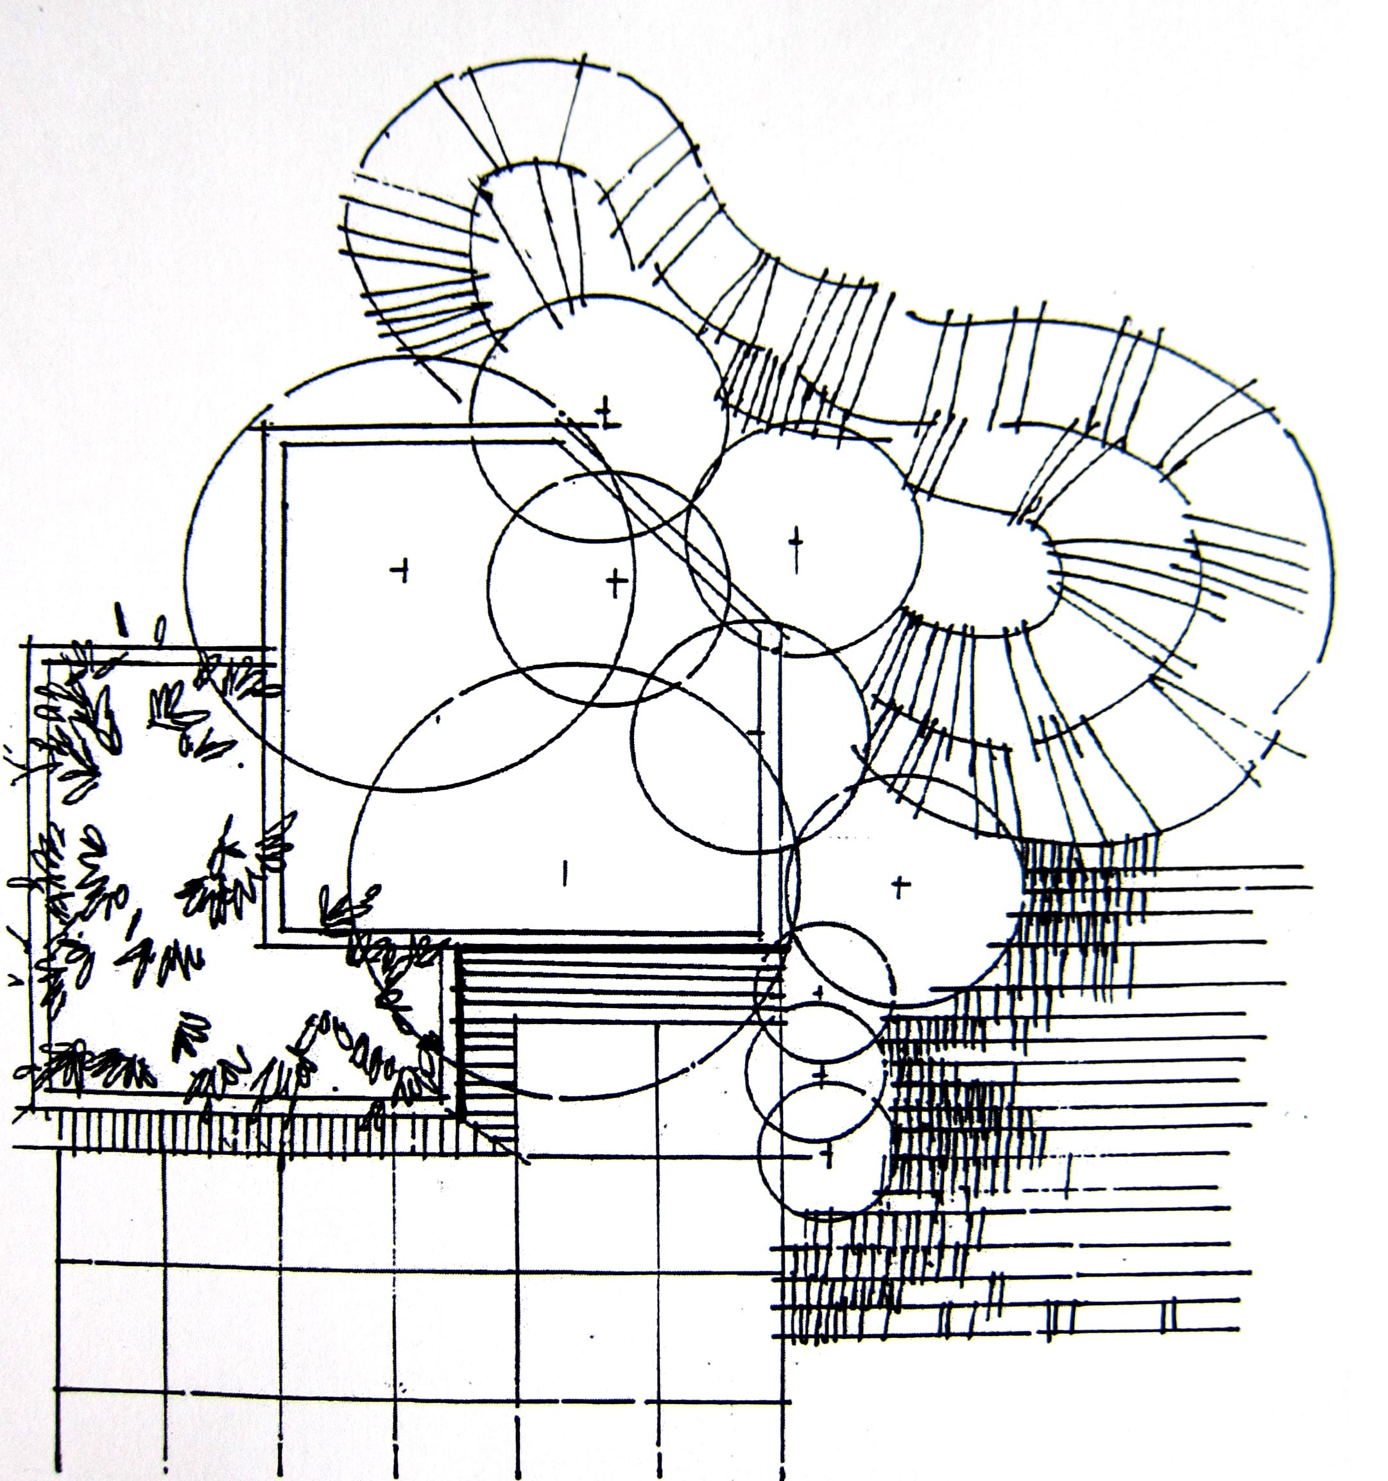
Copy right by BeLoose Graphic Workshop. This image is for personal use only; intend to use in academic, office or other workshop is strictly prohibited.

Visit BeLoose Graphic Workshop at: http://www.beloose.com/?xg_source=msg_mes_network

